Create an ASP.NET Core web app in Azure

06/14/2017 4 minutes to read Contributors

* [Cephas Lin](https://github.com/cephalin)

* [Lisa Costantino](https://github.com/Lisaco88)

* [Sayed Ibrahim Hashimi](https://github.com/sayedihashimi)

* [Robert Outlaw](https://github.com/rloutlaw)

Note

This article deploys an app to App Service on Windows. To deploy to App Service on *Linux*, see [Create a .NET Core web app in App Service on Linux](https://docs.microsoft.com/en-us/azure/app-service/containers/quickstart-dotnetcore).

[Azure Web Apps](https://docs.microsoft.com/en-us/azure/app-service/app-service-web-overview) provides a highly scalable, self-patching web hosting service. This quickstart shows how to deploy your first ASP.NET Core web app to Azure Web Apps. When you're finished, you'll have a resource group that consists of an App Service plan and an Azure web app with a deployed web application.

Note

If you're looking for how to build and deploy an ASP.NET Framework Web App, that article is available [here](https://docs.microsoft.com/en-us/azure/app-service/app-service-web-get-started-dotnet-framework).

Prerequisites

To complete this tutorial:

* Install [Visual Studio 2017](https://www.visualstudio.com/downloads/) with the following workloads:
  + **ASP.NET and web development**
  + **Azure development**

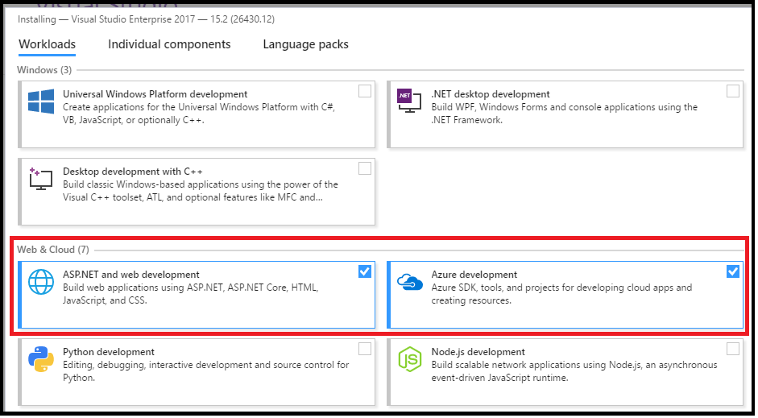

If you don't have an Azure subscription, create a [free account](https://azure.microsoft.com/free/?ref=microsoft.com&utm_source=microsoft.com&utm_medium=docs&utm_campaign=visualstudio) before you begin.

Create an ASP.NET Core web app

In Visual Studio, create a project by selecting **File > New > Project**.

In the **New Project** dialog, select **Visual C# > Web > ASP.NET Core Web Application**.

Name the application *myFirstAzureWebApp*, and then select **OK**.

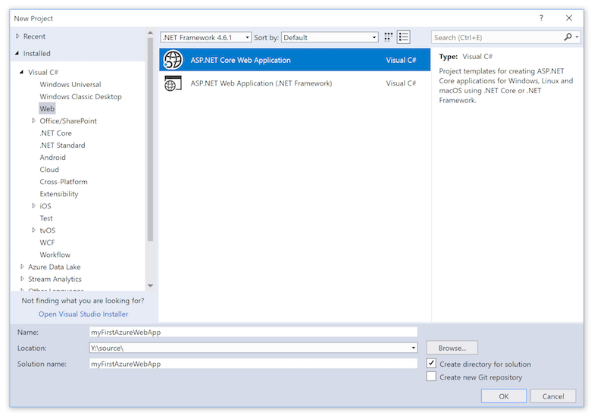

You can deploy any type of ASP.NET Core web app to Azure. For this quickstart, select the **Web Application** template, and make sure authentication is set to **No Authentication**.

Select **OK**.

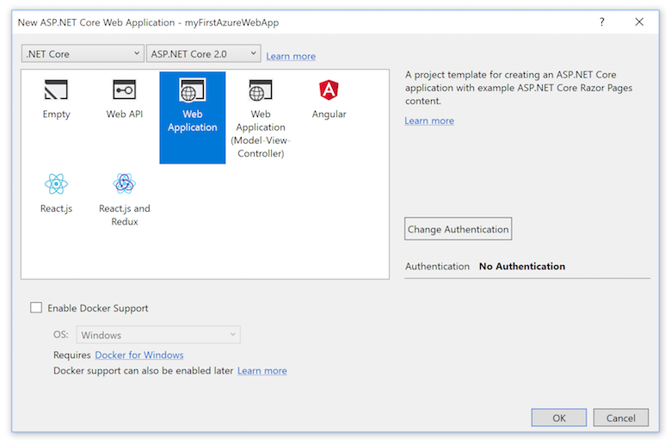

Once the ASP.NET Core project is created, the ASP.NET Core welcome page will be displayed, providing numerous links to resources to help you get started.

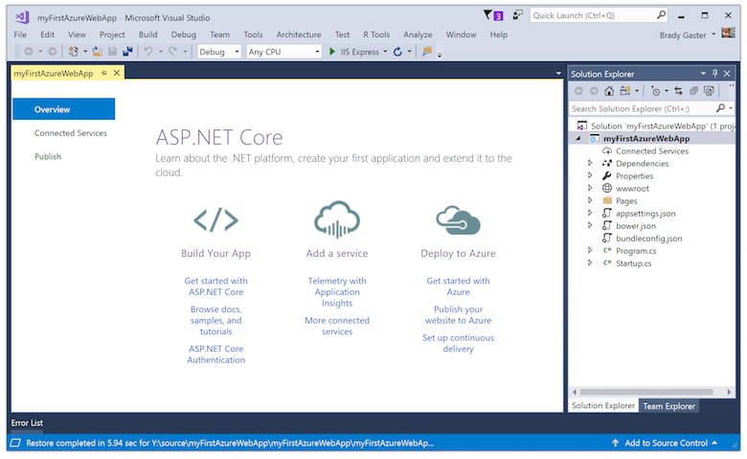

From the menu, select **Debug > Start without Debugging** to run the web app locally.

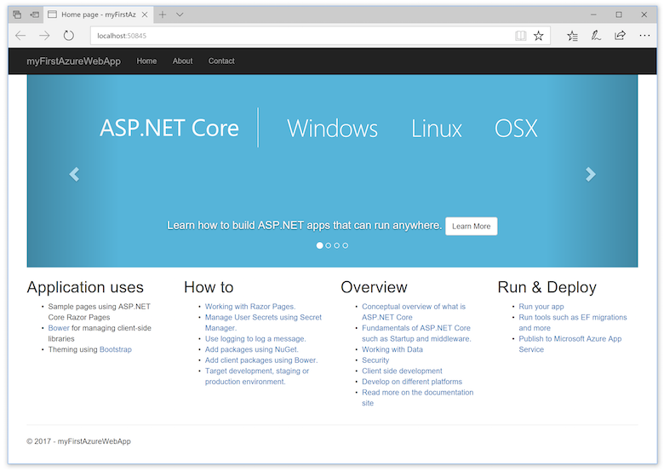

Publish to Azure

In the **Solution Explorer**, right-click the **myFirstAzureWebApp** project and select **Publish**.

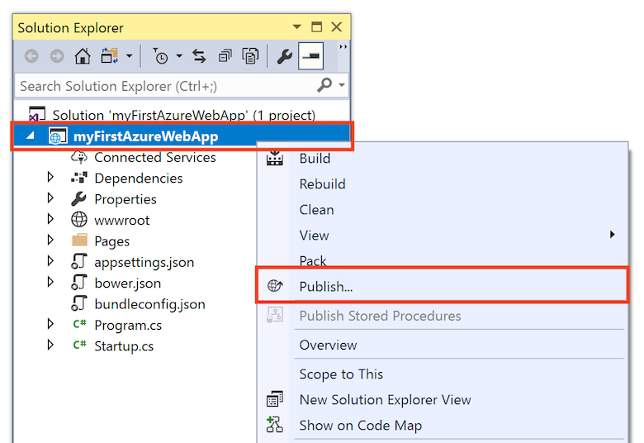

Make sure that **Microsoft Azure App Service** is selected and select **Publish**.

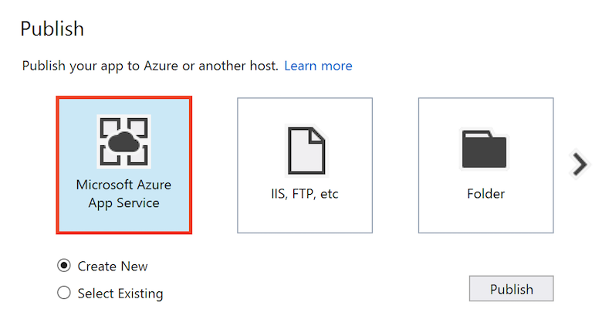

This opens the **Create App Service** dialog, which helps you create all the necessary Azure resources to run the ASP.NET Core web app in Azure.

Sign in to Azure

In the **Create App Service** dialog, select **Add an account**, and sign in to your Azure subscription. If you're already signed in, select the account containing the desired subscription from the dropdown.

Note

If you're already signed in, don't select **Create** yet.

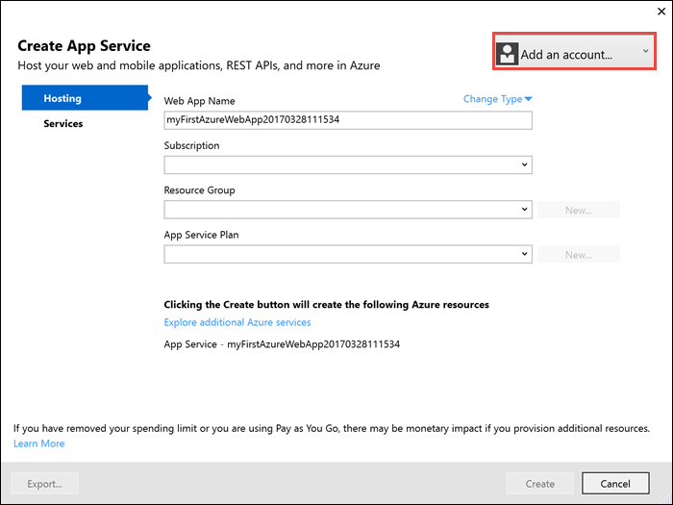

Create a resource group

A [resource group](https://docs.microsoft.com/en-us/azure/azure-resource-manager/resource-group-overview#terminology) is a logical container into which Azure resources like web apps, databases, and storage accounts are deployed and managed.

Next to **Resource Group**, select **New**.

Name the resource group **myResourceGroup** and select **OK**.

Create an App Service plan

An [App Service plan](https://docs.microsoft.com/en-us/azure/app-service/azure-web-sites-web-hosting-plans-in-depth-overview) specifies the location, size, and features of the web server farm that hosts your app. You can save money when hosting multiple apps by configuring the web apps to share a single App Service plan.

App Service plans define:

* Region (for example: North Europe, East US, or Southeast Asia)
* Instance size (small, medium, or large)
* Scale count (1 to 20 instances)
* SKU (Free, Shared, Basic, Standard, or Premium)

Next to **App Service Plan**, select **New**.

In the **Configure App Service Plan** dialog, use the settings in the table following the screenshot.

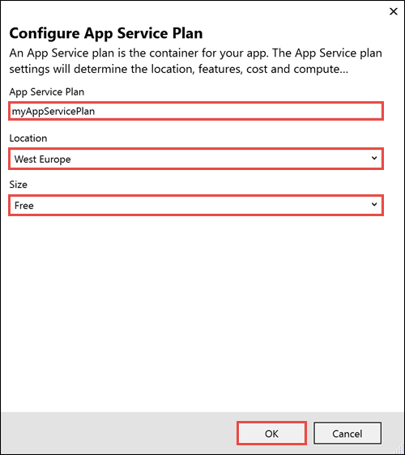

| Setting | Suggested Value | Description |
| --- | --- | --- |
| App Service Plan | myAppServicePlan | Name of the App Service plan. |
| Location | West Europe | The datacenter where the web app is hosted. |
| Size | Free | [Pricing tier](https://azure.microsoft.com/pricing/details/app-service/?ref=microsoft.com&utm_source=microsoft.com&utm_medium=docs&utm_campaign=visualstudio) determines hosting features. |

Select **OK**.

Create and publish the web app

In **Web App Name**, type a unique app name (valid characters are a-z, 0-9, and -), or accept the automatically generated unique name. The URL of the web app is http://<app_name>.azurewebsites.net, where <app_name> is your web app name.

Select **Create** to start creating the Azure resources.

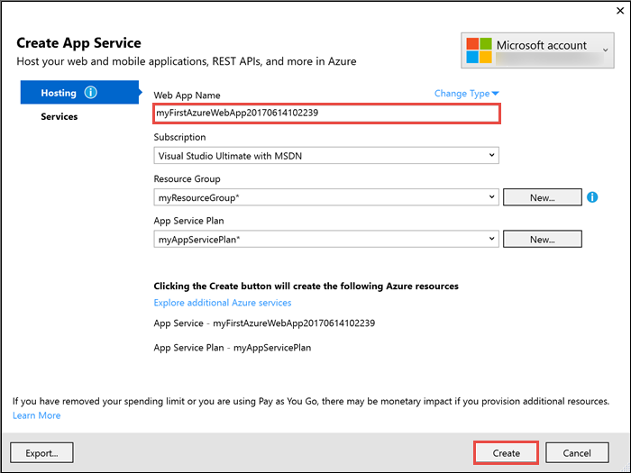

Once the wizard completes, it publishes the ASP.NET Core web app to Azure, and then launches the app in the default browser.

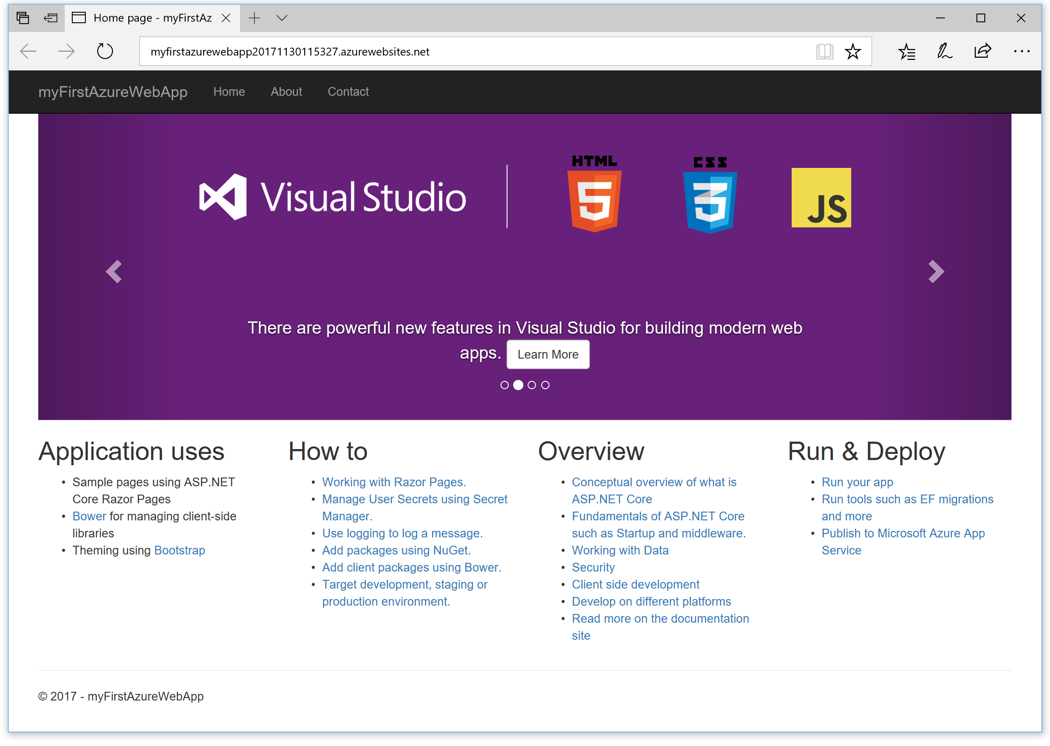

The web app name specified in the [create and publish step](https://docs.microsoft.com/en-us/azure/app-service/app-service-web-get-started-dotnet#create-and-publish-the-web-app) is used as the URL prefix in the format http://<app_name>.azurewebsites.net.

Congratulations, your ASP.NET Core web app is running live in Azure App Service.

Update the app and redeploy

From the **Solution Explorer**, open *Pages/Index.cshtml*.

Find the <div id="myCarousel" class="carousel slide" data-ride="carousel" data-interval="6000">HTML tag near the top, and replace the entire element with the following code:

HTMLCopy

<div class="jumbotron">

<h1>ASP.NET in Azure!</h1>

<p class="lead">This is a simple app that we’ve built that demonstrates how to deploy a .NET app to Azure App Service.</p>

</div>

To redeploy to Azure, right-click the **myFirstAzureWebApp** project in **Solution Explorer** and select **Publish**.

In the publish page, select **Publish**.

When publishing completes, Visual Studio launches a browser to the URL of the web app.

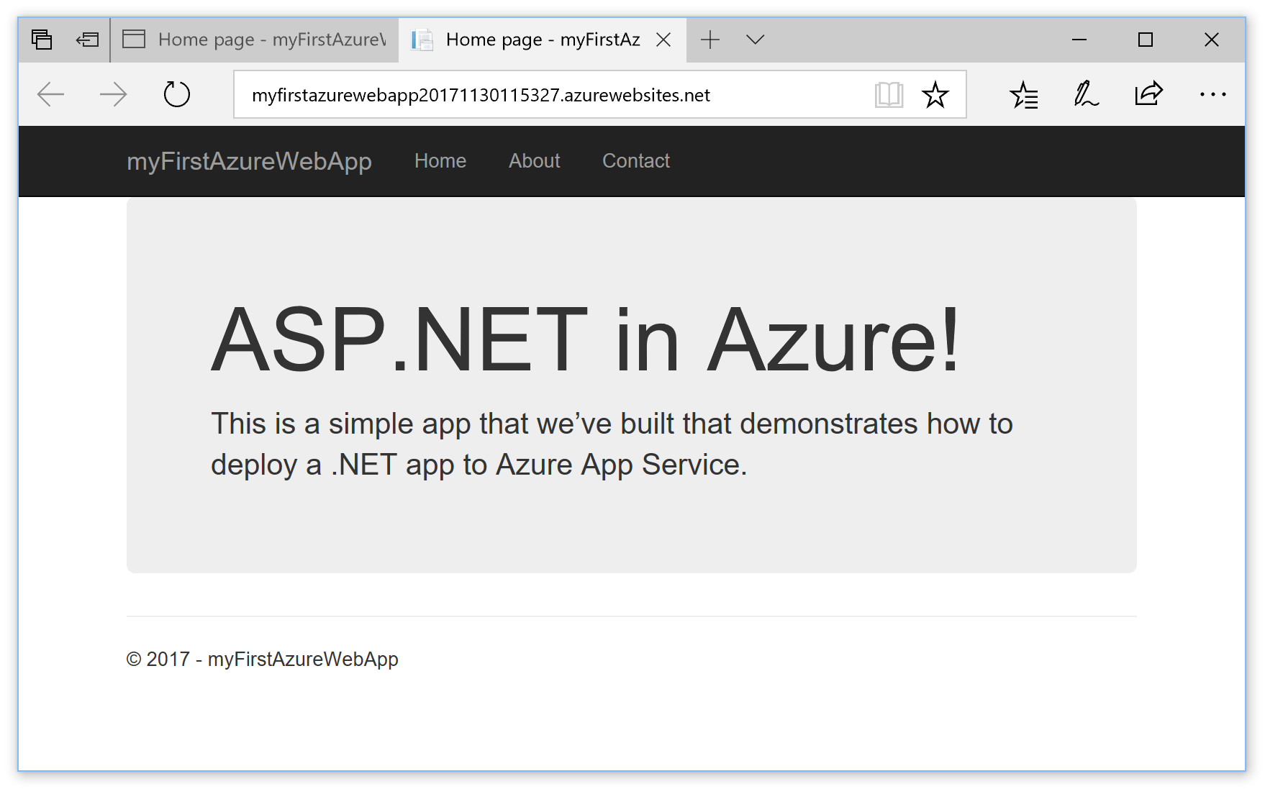

Manage the Azure web app

Go to the [Azure portal](https://portal.azure.com/) to manage the web app.

From the left menu, select **App Services**, and then select the name of your Azure web app.

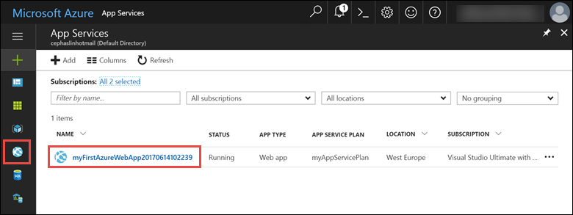

You see your web app's Overview page. Here, you can perform basic management tasks like browse, stop, start, restart, and delete.

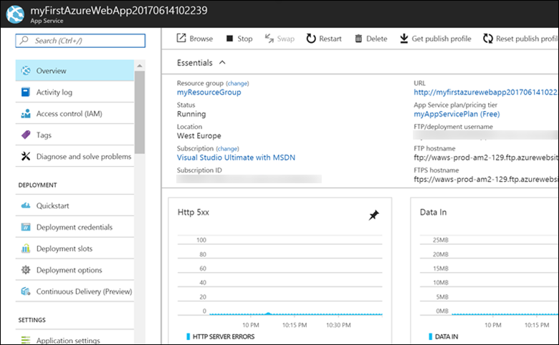

The left menu provides different pages for configuring your app.

Clean up resources

In the preceding steps, you created Azure resources in a resource group. If you don't expect to need these resources in the future, you can delete them by deleting the resource group.

From the left menu in the Azure portal, select **Resource groups** and then select **myResourceGroup**.

On the resource group page, make sure that the listed resources are the ones you want to delete.

Select **Delete**, type **myResourceGroup** in the text box, and then select **Delete**.

Next steps